Red Cloud Renewable
P.O. Box 1609
Pine Ridge, SD 57770
605-441-1140

Solar Tribal Train the Trainer (T4) Program
Application and Commitment Form
2021
Instructions
- Please fill out this Application Form and return it to us via email or regular mail by May 1, 2021 even if you have filled out the form before.
- Please sign and return the Commitment Form as well by May 1. You can mail it or a send a clear picture from your phone to 970-391-0148. We expect final selections to be made by May 30th.

Six students have already been selected in 2020. We have an additional three scholarships available and there is significant interest so please be prompt and thorough in your responses.

Please do not submit an Application and Commitment Form if you are not 100% able and willing to fully participate in all three 2021 professional level training courses that are listed below, as well as being one of the Trainers at the workshop at the Red Cloud Renewable Energy Center.

Our goal is to help Native America become more energy independent and less reliant on fossil fuels.
Therefore, while your educational background and renewable energy experience is important to us, we are also very interested in what you want to do with this training in the months and years ahead.
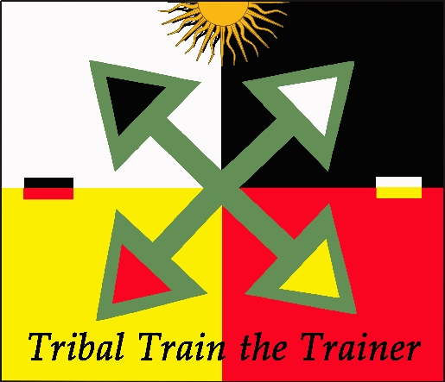
We are developing additional trainings, teaching opportunities and solar projects designed to help our students succeed as solar professionals and we hope you will become part of these continuing education and development opportunities!

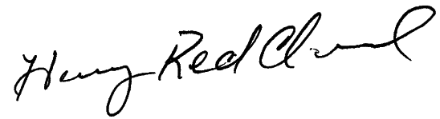
Henry Red Cloud
Executive Director
Red Cloud Renewable
Tribal Train the Trainer – 2021 Application Form

I hereby apply for a scholarship for the Tribal Train the Trainer Program (T4).

Personal Information

Name:
Mailing Address:
City: State: Zipcode:
Telephone:
Email:

Years/months at this address:

Current or last job and related job skills (e.g. carpentry, electrical, plumbing etc):

Are you an enrolled member of a Native American Tribe?
If so, which tribe?

Have you taken any solar or other renewable energy training?
If so, please list types of training with approximate dates and name of instructor.

Have you any teaching experience (renewable energy or any other kind)? Please explain:

Have you worked on any solar or other renewable energy projects?

What was your role on the projects (e.g. Installer?, Designer?, Supervisor?, Sales? Etc.)

Plans for AFTER the Tribal Train the Trainer Workshops
What do you want to do next?

Please respond to only those options that you want to do

- I want to create my own solar business. Yes_______ No ______
If yes, what assistance do you need to get it started? (e.g. tools?, business training?, a truck? etc)

- I want to help RCR grow and expand to help more tribal members by being an RCR teacher and helping to provide training at the Red Cloud Renewable Energy Center. Yes_______ No ______
If yes, why?

- I want to teach/provide training for Solar Energy International. Yes_______ No ______
If yes, why?

- I want to acquire other types of renewable energy skills at the Red Cloud Renewable Energy Center (e.g. solar furnaces, weatherization, hot water, water pumping, mobile solar power centers, building with compressed earth blocks (CEBs)). Yes_______ No ______

Please indicate what training you would prefer most.

- I want to return to my Tribe and help them develop solar projects. Yes_______ No ______
If so, how?

- Part of our goal is to further develop Red Cloud Renewable as a premiere tribal solar training and project implementer including helping tribes develop their own solar projects. We anticipate our Trainers being a key part of this expansion across the northern Plains. Would you be willing to help work on solar projects developed on other tribe’s lands? Yes_______ No ______

- I want to get a job with a tribal (or non-tribal?) solar company? Yes_______ No ______

- We have developed a very positive working relationship on the Lookout Solar Park project - a 110-megawatt solar generating facility on Pine Ridge just 45 minutes from Henry and the Red Cloud Renewable Energy Center. They have acquired all necessary approvals and expect to start the project in the Summer of 2021. We expect to contract with them to do some of the panel installation, training and/or supervision on this 840-acre solar generating facility. Would you be interested in working on this project in 2021? Yes_______ No ______

- To support our efforts to provide more advanced training for our T4 and other students, this summer we will be building 1-2 additional new solar labs at RCREC (June, July and/or August) and improving the overall facility. These will better allow us to provide other types of professional level training for our students. Great experience! Would you be able to volunteer some time (only meals and lodging provided), to help us make these improvements? Yes_______ No ______

If yes, can you estimate when you might be available to help and for how long?

- How else can we help you develop as an important part of the tribal solar professional?

Please return this completed Application to our Colorado office via either email or regular mail before May 1. Students will be selected by May 30th.

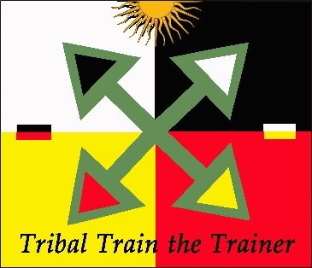
Email: richard@redcloudrenewable.org Phone: 970-391-0148

Mailing Address:
Richard Fox
Red Cloud Renewable
112 Meadow Lane
Fort Collins, CO 80524

Tribal Train the Trainer (T4)
Commitment Agreement (2021)
Name:

I hereby commit to being a student in the Tribal Train the Trainer Program (T4).

If selected, I commit to attending all four of the classes listed below on the Pine Ridge Reservation in South Dakota. I also agree to participate as a trainer (with RCR and SEI supervision and assistance) in teaching SEI Course 101 to tribal trainees at the Red Cloud Renewable Energy Center.

I agree that helping tribal communities move towards energy independence is an important personal goal and part of my future as a solar professional.

Tribal Train the Trainer (2021) – Workshop and Certification Testing Dates
COVID Impacted – All Date to be determined – Probably June/ July 2021
TBD Session 1 – SEI PV101 (Grid-Direct)
TBD Session 2 – SEI PV201 Lab (Grid-Direct)
TBD Session 3 - Combined SEI PV203 and PV301 Lab (Battery-Based)
TBD NABCEP National certification test - At RCREC
TBD Session 4 (with SEI Trainer on site) – SEI PV101
Open workshop for tribal members taught by T4 graduates

Signature Date

Printed Name Tribe

Please return this signed and completed Commitment Form to our office either via email, regular mail or text ASAP.

Email: richard@redcloudrenewable.org Phone: 970-391-0148

Mailing Address:
Richard Fox
Red Cloud Renewable
112 Meadow Lane
Fort Collins, CO 80524

