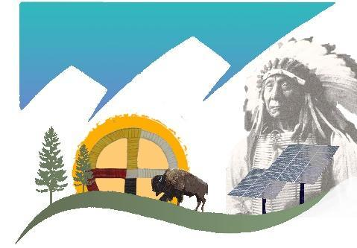
Red Cloud Renewable
P.O. Box 1609
Pine Ridge, SD 57770
605-441-1140

Solar Tribal Train the Trainer (T4) Program
Application and Commitment Form
2022
Instructions
- Please fill out this Application Form and return it to us via email or regular mail by April 1st.
- Please sign and return the Commitment Form as well by April 1st. You can mail it or send a clear picture from your phone to 970-391-0148. We expect final selections to be made by April 15th

Email: richard@redcloudrenewable.org
Mailing address: Richard Fox, Red Cloud Renewable / 112 Meadow Lane / Fort Collins, CO 80524

If you are not 100% able and willing to fully participate in all three professional level training courses that are listed below, please do not submit an Application and Commitment Form. This includes you being one of the Trainers at the PV 101 workshop at the Red Cloud Renewable Energy Center in August.

Our goal is to advocate for more energy independence and less reliance on fossil fuels within Native American communities. Therefore, while your educational background and renewable energy experience is important to us, we are also very interested in what you want to do with this training in the months and years ahead. Please, consider this as a key component to guide you into this T4 course.

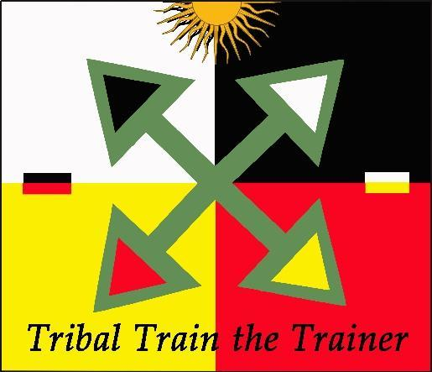
We are developing additional trainings, teaching opportunities, and solar projects designed to help our graduates succeed as solar professionals and we hope you will become part of these continuing education and development opportunities!

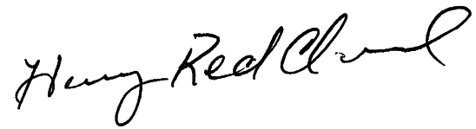
Henry Red Cloud
Executive Director
Red Cloud Renewable
Tribal Train the Trainer – 2022 Application Form

I hereby apply for a scholarship for the Tribal Train the Trainer Program (T4).

Personal Information

Name:
Mailing Address:
City: State: Zip Code:
Telephone:
Email:

Years/months at this address:

Current or last job and related job skills (e.g. carpentry, electrical, plumbing etc):

Are you an enrolled member of a Native American Tribe?
If so, which tribe?

Have you taken any solar or other renewable energy training?
If so, please list types of training with approximate dates and name of instructor.

Have you any teaching experience (renewable energy or any other kind)? Please explain:

Have you worked on any solar or other renewable energy projects?

What was your role on the projects (e.g. Installer?, Designer?, Supervisor?, Sales? Etc.)

Plans for AFTER the Tribal Train the Trainer Workshops
What do you want to do next?

Please respond to only those options that you want to do

- I want to create my own solar business. Yes_______ No ______
If yes, what assistance do you need to get it started? (e.g. tools?, business training?, a truck? etc)

- I want to help RCR grow and expand to help more tribal members by being an RCR teacher and helping to provide training at the Red Cloud Renewable Energy Center. Yes_______ No ______
If yes, why?

- I want to acquire other types of renewable energy skills at the Red Cloud Renewable Energy Center (e.g. solar furnaces, weatherization, hot water, water pumping, mobile solar power centers, building with compressed earth blocks (CEBs)). Yes_______ No ______

Please indicate what training you would prefer most.

- I want to return to my Tribe and help them develop solar projects. Yes_______ No ______
If so, how?

- Part of our goal is to further develop Red Cloud Renewable as a premiere tribal solar training and project implementer including helping tribes develop their own solar projects. We anticipate our Trainers being a key part of this expansion across the northern Plains. Would you be willing to help work on solar projects developed on other tribe’s lands? Yes_______ No ______

- I want to get a job with a tribal (or non-tribal?) solar company? Yes_______ No ______

- We have developed a very positive working relationship on the Lookout Solar Park project - a 110-megawatt solar generating facility being developed on Pine Ridge just 45 minutes from Henry and the Red Cloud Renewable Energy Center. They have acquired all necessary approvals and expect to start the project in the Summer of 2022. We expect to contract with them to do some of the installation, training and/or supervision on this 840-acre solar generating facility. Would you be interested in working on this project in 2022? Yes_______ No ______

- We wish to provide more advanced training for our T4 and other students. This summer we will continue to build additional new solar labs at RCREC (June, July and/or August) and improve the overall facility. These will support other types of professional level training for our current and future students. This is a wonderful opportunity to help build the Red Cloud Renewable community and a great experience to have under your belt! Would you be able to volunteer some time (only meals and lodging provided), to help us make these improvements? Yes_______ No ______

If yes, can you estimate when you might be available to help and for how long?

- How else can we help you develop on your journey into the tribal solar profession?

Please return this completed Application to our Colorado office via either email or regular mail before April 1st.

Final selection of students is expected by April 15th.

Email: richard@redcloudrenewable.org

Mailing Address:
Richard Fox
Red Cloud Renewable
112 Meadow Lane
Fort Collins, CO 80524

Phone: 970-391-0148

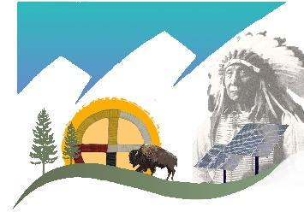
Tribal Train the Trainer (T4)
Commitment Agreement (2022)
Name:

I hereby commit to being a student in the Tribal Train the Trainer Program (T4).

If selected, I commit to attending all four of the classes listed below on the Pine Ridge Reservation in South Dakota. I also agree to participate as a trainer (with supervision and assistance) to teach the PV 101 course to new tribal trainees at the Red Cloud Renewable Energy Center.

I agree that helping tribal communities move towards energy independence is an important personal goal and part of my future as a solar professional.

Tribal Train the Trainer (2022) – Workshop and Certification Testing Dates
June 13 (Su) Arrive at the Sacred Earth Lodge
June 14 (Mo) – 18 (Fr) PV101 Grid-tied classroom
June 19 (Sa) – 20 (Su) Weekend off. Meals will be served if you want to stay.
June 21 (Mo) – 25 (Fr) PV 201 – Grid-tied LABS at the new RCR Solar Lab Facility.
June 26 (Sa) – July 6th (Tu) Time off to recharge and take care of families and personal life.
July 7 (We) – 14 (We) PV 203 and 301 – Battery based. Study day on July 11 (Su).
July 15 (Th) – 10 AM NABCEP National Certification testing at RCR
August 9 (Mo) – 13 (Fr) All 2021 graduates will teach the PV 101 course to other Native Americans with RCR and Remote Energy teaching assistance.

Signature Date

Printed Name Tribe

Please return this signed and completed Commitment Form via email or send a clear picture from your phone to 970-391-0148 by April 1st.

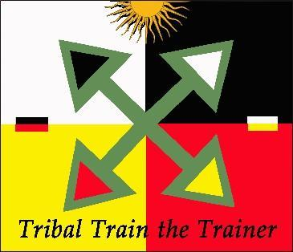
Email: richard@redcloudrenewable.org

Mailing Address:
Richard Fox
Red Cloud Renewable
112 Meadow Lane
Fort Collins, CO 80524

Phone: 970-391-0148

